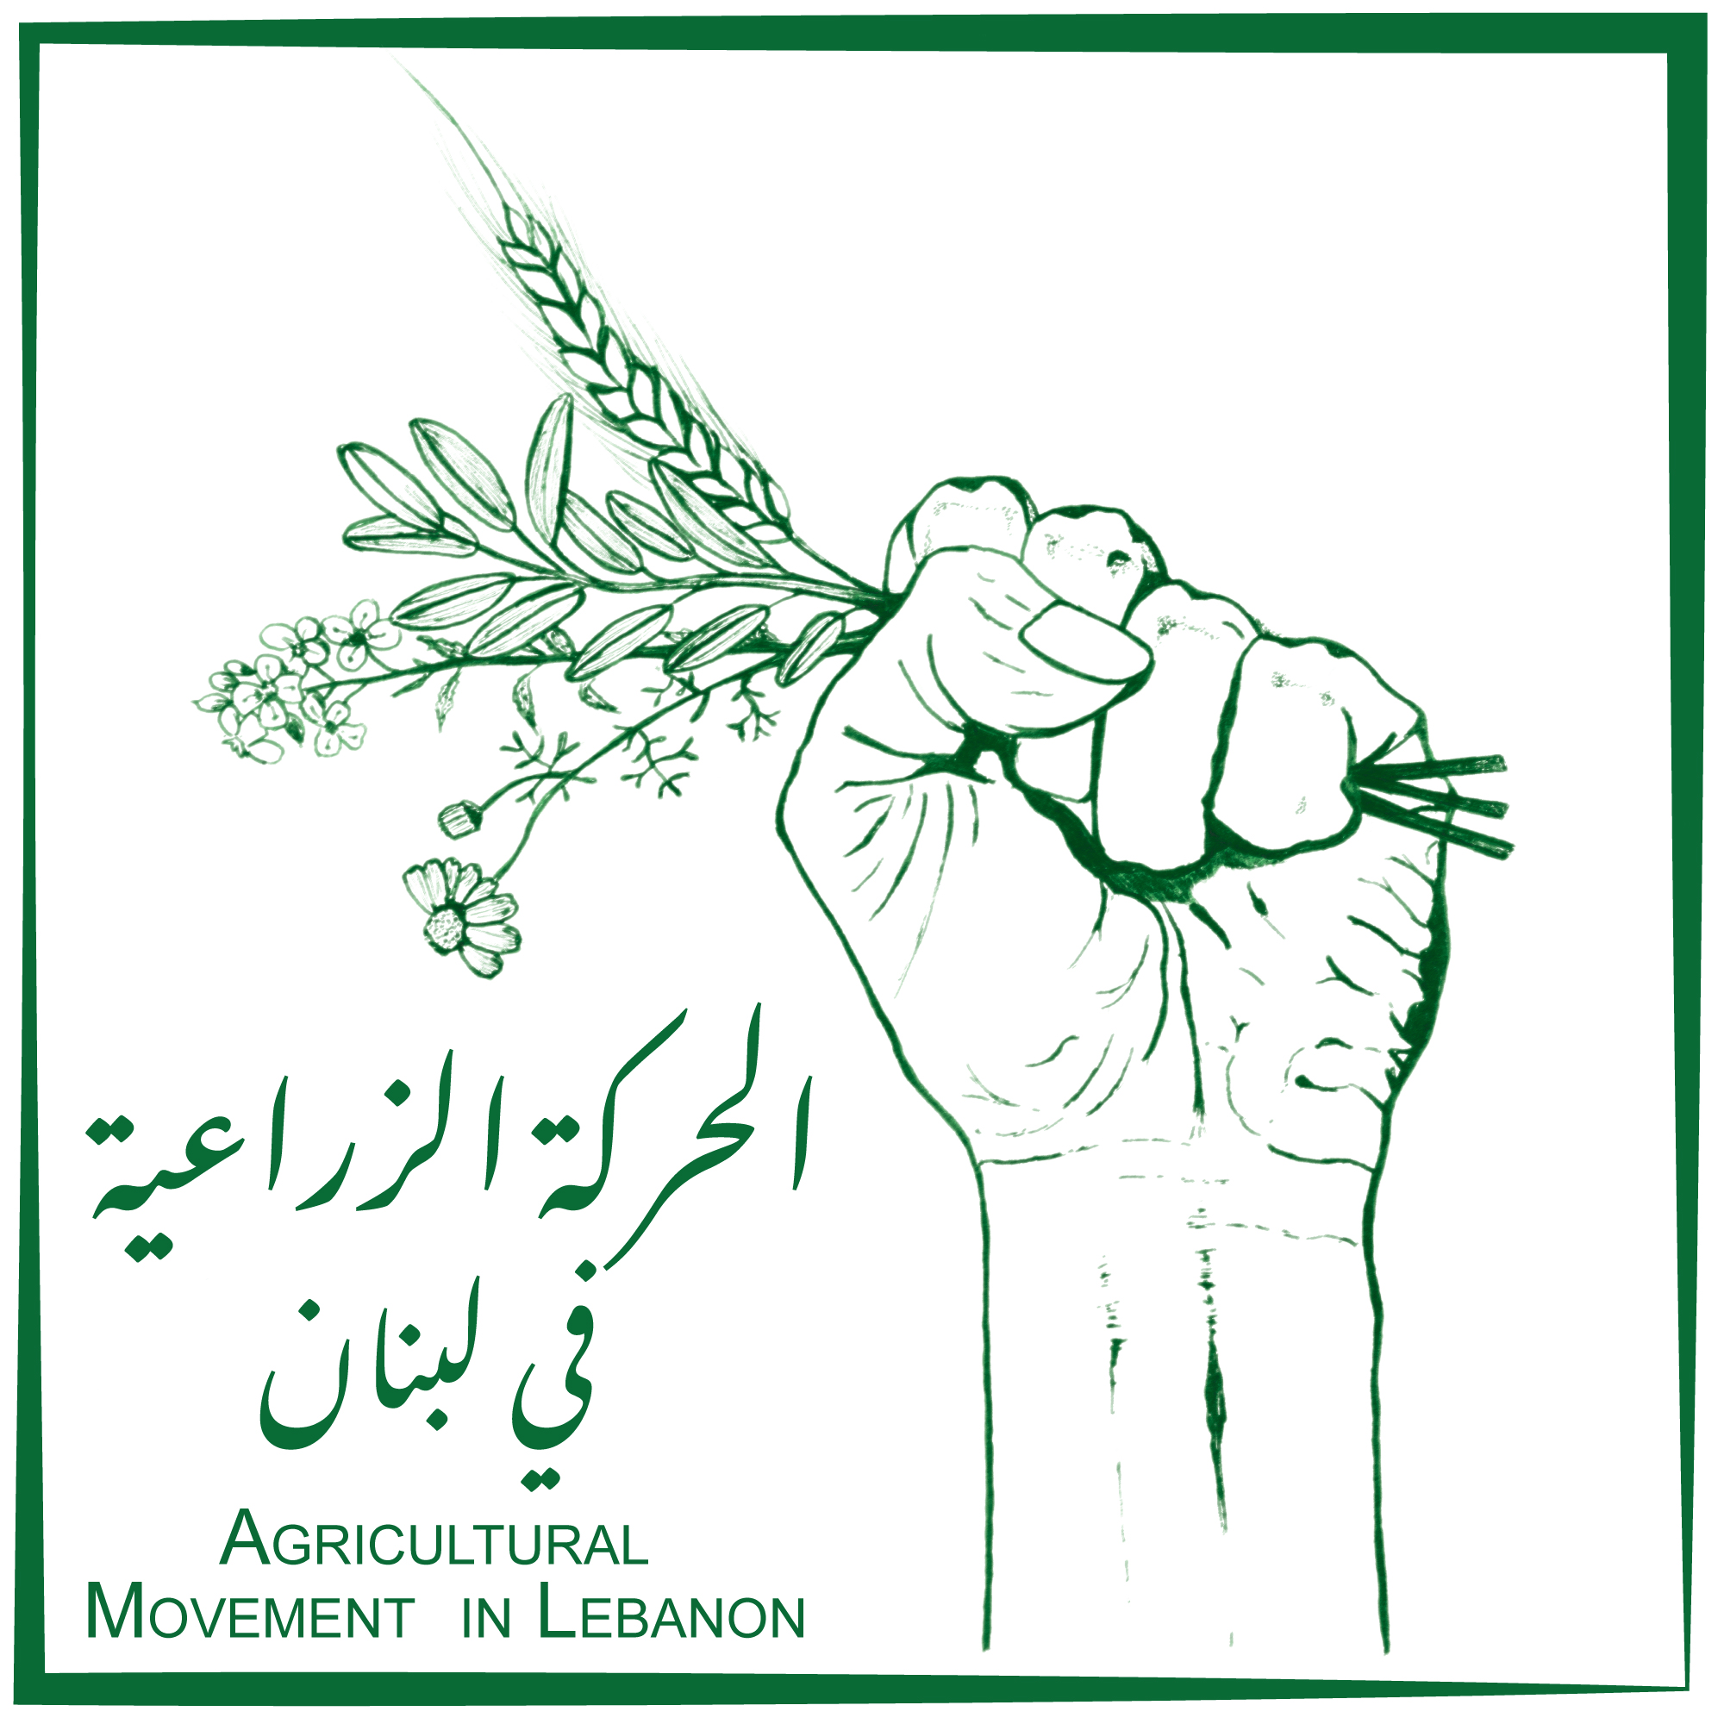

Anti-Corruption, Anti-Fraud, and Conflict of Interest Policy

Developed in December 2023

Table of Contents
INTRODUCTION 4
Policy Statement 4
Why AAP 4
What Is AAP 4
What are the Pillars of AAP 5
Pillar 1. Participation 5
Pillar 2. Feedback and Complaints 5
Pillar 3. Coordination and Partnership 6
AAP Guiding Principles 6
Principle 1. Taking Account 6
Principle 2. Giving Account 7
Principle 3. Being Held to Account 7
AAP PROCESS AT Just.Childhood 8
Integrating AAP into Needs Analysis and Community Engagement 8
Integrating AAP into Program Design and Implementation 9
Integrating AAP into Monitoring and Reporting 9
AAP IN EMERGENCIES 9

AIM AND SCOPE
This comprehensive policy framework underscores Agri-movement's dedication to fostering a culture of transparency, accountability, and ethical conduct, ensuring that all our endeavors are conducted with the highest standards of integrity and in alignment with our mission and values. It is developed to support Agri-movement guarantee ethical behavior and promote its integrity primarily among the farmers it exists to serve and secondarily for all stakeholders it works with, including those that support the movement. As such, this policy shall be applicable to all our members and committees, our general assembly, our executive committee, and our coordination committee. It shall also be applicable to volunteers and consultants working with us.

ANTI-CORRUPTION GUIDELINES
Agri-movement is deeply committed to maintaining the utmost standards of integrity and ethical behavior across its members and stakeholders, regardless of the specific project or intervention they are engaged in. The movement takes a stringent zero-tolerance stance against corruption.
In the context of Agri-movement, corruption is defined as any misuse of power occurring within the framework of a project, intervention, or activity carried out by our members, affiliated entities, or stakeholders.
This policy explicitly prohibits all individuals covered by it from either offering or accepting any form of bribery. Additionally, the guidelines restrict individuals engaged with Agri-movement from accepting gifts with a value exceeding $30 from beneficiaries, vendors, or contractual parties while being engaged with us.
Individuals under this policy are obligated not to misappropriate any property or funds entrusted to them. They are committed to abstaining from any implicit or explicit act of deception, fraud, or breaches of trust designed to exploit their position or contractual relationship with Agri-movement.

ANTI-FRAUD GUIDELINES
Agri-movement is resolutely committed to combatting any potential instances of fraud.
To us, fraud is defined as a deliberate act or omission aimed at deceiving others, resulting in the perpetrator gaining a benefit, whether financial or otherwise, or causing harm to another party. Such fraudulent activities encompass misappropriation of funds, assets, or resources; falsification of documents, records, or reports; involvement in corrupt practices, bribery, or kickbacks; theft, embezzlement, or unauthorized utilization of property; and submission of false claims for reimbursements, allowances, or expenses.
To proactively prevent and address fraud, Agri-movement has established a comprehensive set of measures, including a zero-tolerance approach, accountability, promotion of transparency, and emphasis of transparency.

These proactive measures underscore Agri-movement's commitment to creating a robust framework that not only prevents fraud but also promotes a culture of transparency, accountability, and ethical conduct across all levels.

CONFLICT OF INTEREST GUIDELINES
Members of Agri-movement, whether part of the General Assembly, Executive Committee, Coordination Committee, or any team member, are expressly prohibited from obtaining personal profit or advantage, either directly or indirectly, through their association with Agri-movement. This prohibition extends to their family members or close associates who could potentially gain any form of benefit. It is mandatory for each individual to disclose any personal interests they may have in matters being deliberated by the movement and to abstain from participating in discussions or decisions pertaining to such matters.
In addition, any member, including those in the General Assembly, committees, or teams, must refrain from using client or donor lists for personal or private solicitation purposes during their tenure with Agri-movement. New members joining Agri-movement will receive a copy of this policy, and the Executive Committee will conduct an annual review of the policy during its regular meetings.
All members are expected to recognize that the primary objective of this policy is to safeguard the integrity of Agri-movement and its decision-making processes while cultivating trust in the motives and actions of its members. Therefore, those endorsing this policy understand that compliance is not merely a procedural matter but a commitment to uphold its underlying principles.

INVESTIGATION, REPORTING, & CONSEQUENCES

Reporting Procedures
Any person with a credible concern about a potential violation of this policy is encouraged to report it as follows:
- To the Coordination Committee at the email address xx, with the subject line, "Policy Violation."
- In cases where the report involves a member of the Coordination Committee, to the Executive Committee at the email address xx , with the subject line, "Policy Violation."
Individuals must express their concerns in written form, offering background information and context, including relevant names, dates, and places. It is essential to specify the grounds for their allegation or reasonable suspicion. Reports may be submitted anonymously.

Investigation
Upon receipt of a complaint containing an allegation of corruption, fraud, or a conflict of interest, or when there is a suspicion of such misconduct, the Coordination Committee at Agri-movement shall initiate an investigation in a discreet manner. This investigation will be conducted objectively, impartially, and with meticulous thoroughness.
If any member of the Coordination Committee is involved, then the Executive Committee shall conduct this investigation, with the aid of a third-party advisor if deemed necessary and helpful.
As the investigation unfolds, and considering legal and confidentiality constraints, the individual who raised the concern may be informed of progress and findings. In certain situations, it may become necessary for the reporting individual to provide evidence in criminal or disciplinary proceedings. Only under such circumstances might the identity of the complainant be disclosed after informing him/ her.

Consequences
If the investigation fails to substantiate the suspicions, the matter will be concluded. The person who reported the concern will not face any differential treatment or discrimination, provided that their report was made in good faith, and their confidentiality will remain protected.
Depending on the act’s seriousness, the perpetrator may receive an oral or written reprimand, be referred to mandatory training, be dismissed from Agri-movement. In certain circumstances, and depending on the act, Agri-movement reserves the right to take legal action.

ACKNOWLEDGEMENT
This policy shall be reviewed and accepted by all members of Agri-movement and respective consultants. While consultants will be asked to sign off on the policy as annexed to their agreement, a common sign-off sheet is annexed hereunder to be signed by all members.

SIGN-OFF SHEET

I, the undersigned, am hereby committed to abide by this Policy and its guidelines.
Name | Date | Signature

